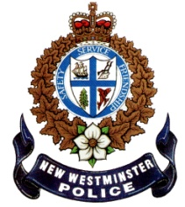 | NEW WESTMINSTER POLICE DEPARTMENT  555 Columbia Street New Westminster, BC V3L 1B2 (604) 525-5411 FAX (604) 529-2401  www.nwpolice.org  David Jones, Chief Constable

Reserve Constable Applicant,

Thank you for your interest in the New Westminster Police Department (NWPD).

We consider our organization progressive leaders in policing whose mission is to keep our community safe by enforcing the law, and preventing and reducing crime. What is imperative for you to know, as a Reserve Constable applicant, is that our mission embraces and includes our volunteers. We are looking for good, committed people to assist us in our efforts to improve the quality of life in our community. The New Westminster Police Department offers many learning opportunities and experiences. We invite you to be part of our team of dedicated professionals.

Please find the attached instructions and the application package to apply for the Reserve Constable Program.

If you have any questions about this application, please feel free to contact me at the email below.

Thank you for your interest and good luck.

Sincerely,

Constable Wendy Bowyer #192
Reserve Constable Coordinator
New Westminster Police Department

Wendy Bowyer
Community Constable, Prevention Services
wbowyer@nwpolice.org

NEW WESTMINSTER POLICE DEPARTMENT
555 Columbia Street, New Westminster, BC V3L 1B2
P: 604-525-5411 F: 604-529-2401 W: www.nwpolice.org

Application Instructions for the
Reserve Constable Program

Please follow the instructions below carefully. Incomplete or illegible applications will not be reviewed.
- Ensure that you meet our minimum requirements prior to commencing the application process. The minimum requirements are attached.

- All questions must be answered. Incomplete application forms will not be processed. If a question is not applicable use “N/A” in the appropriate space. If an entire section is not applicable, one “N/A” in the first available space is sufficient.

- The application form covers numerous areas necessary to determine the suitability of applicants, and also serves as a basis for determining your security clearance.

- If anyone required to be listed in these forms is deceased, please indicate by placing the word “deceased”, followed by the person’s date of death.

- Fill the form out by hand, use black ink and ensure your writing/printing is legible.
If you make an error, do not use white-out. Place a single line through the error and write the correction above or beside.

- The application form must be signed, dated and delivered or mailed to the New Westminster Police Department.

- Ensure you also complete the Consent to Release of Personal and/or Private Information Waiver and Release form.

- All addresses must include the postal code. Use area codes for all phone numbers.
Date of births should be YY-MMM-DD format [85-JAN-04]. All other date formats should follow YY-MMM [10-JUN].

- When answering questions with a yes/no box, please place an “X” in the box you wish to select.

- Unless otherwise instructed, list items in chronological order, beginning with the most recent.
Leave no gaps in dates, between educational institutions, places of employment, etc.

- If extra space is required to answer questions, do not write on the back/flip side of any pages, choose one of the following:
  - If you have printed the application form from the website; just re-print the specific page and continue answering your question
  - If you picked up an application form from the Station, insert a blank page and continue answering your question
Please make sure you indicate that you are continuing to answer on the following page, write the question # that you are continuing to answer and make sure to edit the page number. For example, if you reprinted page 24 then indicate on that page that it is page 24-A.

- All information is subject to verification by investigation. False, misleading, or undisclosed information in this document or at any other stage in the application process will result in the termination of your application, or dismissal.

- Please do not staple or put the application form in any binder, cover or page protector. You may use paperclips or a binder clip if you wish.

- By completing this application, you acknowledge and understand that honesty, integrity, and background are areas that are scrutinized closely when considering applications, and that all questions in this document are necessary for this purpose.

- Ensure that you have submitted all documents in order as listed on the Application Checklist.

- Deliver or mail your application in a sealed envelope to the office of the New Westminster Police Department:

New Westminster Police Department
Attention: Constable Wendy Bowyer
Prevention Services
555 Columbia Street
New Westminster, BC
V3L 1B2

NEW WESTMINSTER POLICE DEPARTMENT
555 Columbia Street, New Westminster, BC V3L 1B2
P: 604-525-5411 F: 604-529-2401 W: www.nwpolice.org

Applicant Minimum Requirements
Reserve Constable Program

APPLICANTS MUST MEET ALL OF THE FOLLOWING MINIMUM REQUIREMENTS
IN ORDER TO HAVE THEIR APPLICATION ACCEPTED.

CITIZENSHIP | Canadian Citizen or Permanent Resident
MINIMUM AGE | 19 years of age or older upon commencement of training
MAXIMUM AGE | Maximum age of 60 years at the completion of training. (Participation in the Reserve Program after age 60 is subject to review by the Chief Constable, or delegate. At that time, the Reserve’s activities may be subject to specific restrictions or the Reserve may be released from the Program. Reserves may not participate in a ride-a-long program after reaching 60 years of age.)
DRIVER’S LICENSE | Valid Class 5 Driver’s License
HIGH SCHOOL EDUCATION | High School graduation certificate or GED
TRAINING | Ability to achieve the designated passing grade on all training
BACKGROUND | Ability to successfully complete a thorough background investigation
SENSITIVITY | Ability to demonstrate sensitivity to people of diverse cultures, lifestyles and ethnicity
VOLUNTEER EXPERIENCE | Demonstrated commitment to the community through preferred volunteer experience
COMMUNICATION SKILLS | Successful completion of the written ETHOS exam. An overview of the ETHOS examination is available on our NWPD website under “exam”.  Excellent verbal and written communication skills.
INTEGRITY | Our department places great emphasis on the ability to positively interact with all members of our community. In previous work, volunteer and social settings, candidates must have consistently demonstrated maturity, responsibility, good character, diplomacy and common sense. Have no criminal record and must have no pending criminal charges before the court. Successful candidates will undergo a polygraph examination.

NEW WESTMINSTER POLICE DEPARTMENT
555 Columbia Street, New Westminster, BC V3L 1B2
P: 604-525-5411 F: 604-529-2401 W: www.nwpolice.org

Applicant Minimum Requirements
Reserve Constable Program

APPLICANTS MUST MEET ALL OF THE FOLLOWING MINIMUM REQUIREMENTS
IN ORDER TO HAVE THEIR APPLICATION ACCEPTED.

COMPUTER SKILLS | Preferred Skill: Strong computer skills and keyboarding ability
FIRST AID CERTIFICATE | Must possess and maintain a current basic first aid certificate with CPR
PHYSICAL ABILITIES | Successful completion of the Police Officer’s Physical Abilities Test (POPAT)  Must undergo a medical exam and provide certification of physical fitness, including good vision and hearing. Visual acuity must be no poorer than 20/40, 20/100 uncorrected and 20/20, 20/30 corrected. (The cost of obtaining the required examinations and certification is the responsibility of the applicant)
LENGTH OF SERVICE | Must be willing to commit to the minimum length of service indicated (2 years minimal)
TRAINING | Must be willing to commit to the minimum training required.  (Approximately 100 hours)
MINIMUM PROGRAM COMMITMENT HOURS | Once training is complete you are expected to commit to a minimum number of volunteer hours per month as well as complete all required mandatory training

NEW WESTMINSTER POLICE DEPARTMENT
555 Columbia Street, New Westminster, BC V3L 1B2
P: 604-525-5411 F: 604-529-2401 W: www.nwpolice.org

Acknowledgement Form
Reserve Constable Program

Acknowledgement Form
I acknowledge and fully understand the following:
1. The New Westminster Police Department Reserve Constable Program is a volunteer program appointed by the New Westminster Police Board on the recommendation of the Chief Constable. Appointments may be rescinded at any time at the discretion of the Chief Constable and that decision is final. Active participation, meeting training standards and personal suitability for the program will be considered in evaluating new and renewal of appointments.
2. Reserve Constable appointments are restricted peace officer appointments and authority is limited to the authority required to perform specific authorized duties, except when called upon by a police officer who, in calling upon a Reserve for assistance, assumes direct supervision of the Reserve.
3. Reserve Constables are under the operational command of the Chief Constable and their primary purpose is to participate in community policing activities relating to public safety and crime prevention on an unarmed basis. (Tier One)
4. All Reserve Constables must familiarize themselves with the governing policies (both internal and external). Reserves are subject to the British Columbia Police Act and the Auxiliary/Reserve (A/R) Code of Conduct as well as specific policies developed by the New Westminster Police Department. Failure to comply with policies and the Code of Conduct may result in dismissal.
5. Reserve Constables are protected from the risk of personal civil liability, except where the conduct is found to be grossly negligent, malicious or an act of willful misconduct. Volunteers to the Reserve Program assume the risk of potential criminal liability for their actions.
6. During the performance of authorized duties, a Reserve Constable must carry a New Westminster Police Department issued identification card and must produce that card upon request. When not performing authorized duties, a Reserve Constable must not identify him/herself as a Reserve Constable, or as having any powers greater than a citizen, other than when called upon to provide assistance to a police officer.
7. All uniforms, equipment and forms of identification issued to a Reserve Constable remain the property of the New Westminster Police Department and must be returned upon request. A Reserve Constable may be held financially responsible for any equipment lost or equipment the Reserve Constable fails to return upon resignation or release from the program.
I have read and understand the above statements and wish to participate in the New Westminster Police Department Reserve Constable Program.
APPLICANT’S SIGNATURE: |  | DATE:
APPLICANT’S PRINT NAME:

NEW WESTMINSTER POLICE DEPARTMENT
555 Columbia Street, New Westminster, BC V3L 1B2
P: 604-525-5411 F: 604-529-2401 W: www.nwpolice.org

Application Checklist
Reserve Constable Program

Applicant Name: | Date Application Submitted:
Applicant Signature:

I am applying for the Reserve Constable Program and confirm that all of the following documentation has been submitted with my application and placed in a sealed envelope in the following order:

- Application Checklist – Reserve Constable Program
- Two Passport Style Photographs in Color [attach to this checklist with a paperclip]
- Acknowledgement Form
- Application Form-printed single sided only
- Consent to Release of Personal and/or Private Information, Waiver and Release
- Police Officers’ Physical Abilities Test Medical Examination/Waiver Form
- PAR-Q & You Form
- Police Officers’ Physical Abilities Test Liability Release & Indemnity Form
- Vision Report for Police Service Form
- Audiometric Report for Police Service Form
- Query Information Form
- RCMP Consent for Check for a Sexual Offence
- Copy of Birth Certificate
- Proof of Citizenship or Permanent Residency if applicable
- Copy of S.I.N. Card
- Copy of Driver’s License
- Official Driver’s Abstract
- Certified copy of High School Education Transcripts
- Certified copy of Post Secondary Transcripts
- Copy of First Aid Certificate

- Provide copies of any other supporting documentation you feel necessary to submit with your application.
- Please do not staple or put the application form in any binder, cover or page protector.
- You may use paperclips or binder clips if you wish.
- Application is to be submitted in a sealed envelope.
- Please note that it is your responsibility to check and complete all documents prior to submission.
- Incomplete or illegible applications will not be reviewed.

NEW WESTMINSTER POLICE DEPARTMENT
555 Columbia Street, New Westminster, BC V3L 1B2
P: 604-525-5411 F: 604-529-2401 W: www.nwpolice.org

Consent to Release of Personal and/or
Private Information, Waiver and Release

FULL NAME:
FORMERLY KNOWN AS:
DATE OF BIRTH: YY-MMM-DD

I, _____________________________________________________________________, having applied for a position with the New Westminster Police Department, and recognizing that I am required to supply information to be used to determine my qualifications, moral character, honesty and suitability for volunteering with the Department, herby request and authorize the full disclosure of any and all records, files, notes, reports, opinions or other information concerning me, including employment files and records, performance evaluations, discipline records, background investigation files, polygraph reports, medical, psychiatric and psychological files and reports, complaints or grievances filed by or against me, training files, education files, school records and transcripts, credit rating and history files, income tax files, records and returns, driving records, military records, criminal records and police, probation and parole reports.
I hereby authorize the New Westminster Police Department to make such investigations as they deem necessary to determine approval or disapproval of this application. I understand that the New Westminster Police Department will have the final say in the approval or rejection of this application, and the criteria and method they use in arriving at their decision, will not be questioned or objected to by me and I will have no grievance against the New Westminster Police Department or the Corporation of the City of New Westminster in this regard.

I waive the right to read or review any information received by the New Westminster Police Department.

I release any individual, company, government agency, or public body and their representatives, agents and employees from any claim or action whatsoever which may result from furnishing the above information to the New Westminster Police Department.

A photocopy of this release is to be considered as valid as an original waiver even though it does not contain an original of my signature. This waiver is valid for a period of one year from the date of signature.

APPLICANT SIGNATURE: |  | DATE:

NEW WESTMINSTER POLICE DEPARTMENT
555 Columbia Street, New Westminster, BC V3L 1B2
P: 604-525-5411 F: 604-529-2401 W: www.nwpolice.org

Police Officers’ Physical Abilities Test
Medical Examination/Waiver

APPLICANT’S FULL NAME:
APPLICANT’S ADDRESS:
DATE OF BIRTH: YY-MMM-DD

This person is an applicant for the position of Reserve Constable with the New Westminster Police Department. He/she is required to perform a Police Officers’ Physical Abilities Test (POPAT). The POPAT test is designed to simulate and measure ones’ physical ability. The test was developed by exercise physiologist and is based on their research findings. Their research has identified that the usual physical components of a response to a critical incident may involve quick action in getting to the problem, intensive heavy work resolving the problem and then removing the problem. The test is conducted in a gymnasium and consists of running 400 meters (1/4 mile), which includes climbing up and down stairs, jumping over low obstacles, pushing/pulling heavy weights (80lbs/37kg) then lifting and carrying a “dead weight” of 100lbs/45kg over a distance of 15 meters/50ft. It was found that most test participants experienced maximal heart rate during the test. This indicates brief (up to 4 minutes) but maximal stress being placed on the cardiovascular system. To minimize the chance of precipitating a major cardiovascular event, we are requesting that this person be examined to determine his/her employment and test risk potential.
In addition to your usual examination, we request your assessment of this person with respect to factors which may place him/her at risk during this test or during future Reserve Constable related duties:
- Hypertension with possible causative factors
- Diabetes Mellitus
- Known heart disease or symptomatic cardiovascular disease including angina, breathlessness, palpitations, edema, syncope, dizziness, or any other known symptoms
- Low fitness levels
- Acute systemic infections including viral respiratory infections
- Muscular and/or skeletal problems which may affect physical performance or present long-term limitations
- Any other areas of concern

In your opinion, is this person able to safely participate in and complete a physical abilities test, such as the POPAT? |  |  |  |  |  | YES |  | NO
COMMENTS:
DATE: |  |  | DR. SIGNATURE:
 |  |  | DR. STAMP:
NOTE: Physician – Please return this form to the applicant.
NOTE: Applicant – Please submit this completed form with your application.

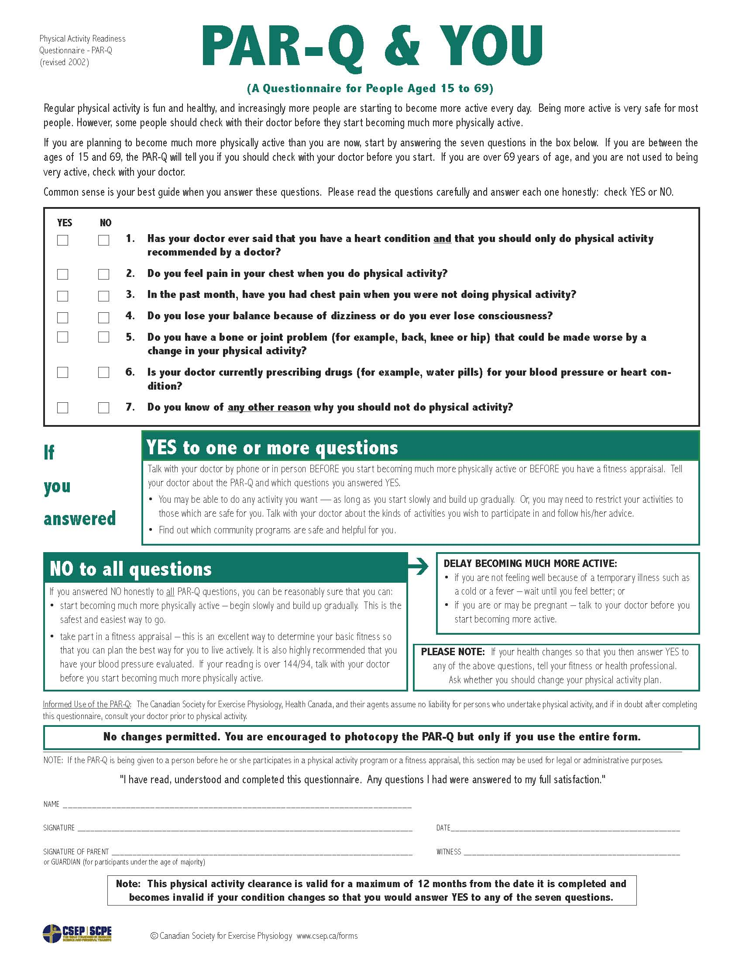

NEW WESTMINSTER POLICE DEPARTMENT
555 Columbia Street, New Westminster, BC V3L 1B2
P: 604-525-5411 F: 604-529-2401 W: www.nwpolice.org

Police Officers’ Physical Abilities Test
Liability Release and Indemnity

APPLICANT’S FULL NAME:
DATE OF BIRTH: YY-MMM-DD

The undersigned wishes to participate in a physical test designed to produce maximal heart rate (hereafter referred to as the “Test”) and recognizes this generally as a safe but challenging experience, and also recognizes that any such physical activity involves some risk. The Test will be conducted by the New Westminster Police Department (hereafter referred to as “NWPD”).
DISCLAMER:
NWPD will not be held responsible in any way for any injury, loss or damage (including death) suffered by any person participating in any part of the Test, as conducted by NWPD for any reason whatsoever including negligence on the part of NWPD, its employees, volunteers, agents, servants or representatives.
AGREEMENT:
In consideration of NWPD allowing me to participate in the Test and any associated activity, I agree to RELEASE and SAVE HARMLESS AND INDEMNIFY NWPD, it’s employees, volunteers, agents, servants or representatives from and against all claims, demands, actions, costs and expenses, and from all claims or demands whatever in law or in equity, in respect to death, injury, loss or damage to my person or property whatsoever and howsoever caused, arising out of, or in connection with, my taking part in the Test and/or any associated activity, notwithstanding that the same may have been contributed to or occasioned by any act or failure to act including without limitation, the negligence of NWPD, its employees, volunteers, agents, servants or representatives. I am aware of the risks inherent in participating in the Test and/or any associated activity. I further understand that the risks involved are also relative to my own state of fitness, health, awareness, and the skill and care with which I conduct myself during the Test. I voluntarily assume those risks and waive notice of call conditions, dangers or otherwise, in or about the Test. I agree to assume all risks involved before, during and after the Test. I agree that this Release shall bind my heirs, executors, and administrators and assigns.
I, |  | , acknowledge having read this entire Liability Release
and Indemnity and I understand and agree to be bound by the conditions herein.

Applicant Signature |  | Witness Signature
Date |  | Witness Name (Print)
 |  | Date

NEW WESTMINSTER POLICE DEPARTMENT
555 Columbia Street, New Westminster, BC V3L 1B2
P: 604-525-5411 F: 604-529-2401 W: www.nwpolice.org

Vision Report for Police Service

TO BE COMPLETED BY THE APPLICANT:
APPLICANT’S FULL NAME:
APPLICANT’S ADDRESS:
DATE OF BIRTH: YY-MMM-DD |  | HAVE YOU EVER HAD EYE SURGERY? |  | - YES | - NO
IF YES, PLEASE INDICATE THE TYPE OF PROCEDURE AND THE DATE IT WAS PERFORMED:

TO BE COMPLETED BY THE ATTENDING OPHTHALMOLOGIST / OPTOMETRIST:
DATE OF EXAMINATION: YY-MMM-DD
- VISUAL ACUITY |  |  | WITHOUT VISUAL AID |  |  | WITH BEST POSSIBLE CORRECTION
 |  | RIGHT EYE | 20 / |  |  | 20 /
 |  | LEFT EYE | 20 / |  |  | 20 /
 |  | BOTH EYES | 20 / |  |  | 20 /
- HORIZONTAL FIELD OF VISION |  |  | TEMPORAL |  |  | NASAL
 |  | RIGHT EYE | Degrees: | - NORMAL  - ABNORMAL |  | Degrees: |  | - NORMAL  - ABNORMAL
 |  | LEFT EYE | Degrees: | - NORMAL  - ABNORMAL |  | Degrees: |  | - NORMAL  - ABNORMAL
 |  | BINOCULAR VISION (DEPTH PERCEPTION): |  |  | - NORMAL |  | - ABNORMAL
COMMENTS:
- COLOUR VISION |  | DETERMINED BY PSEUDO-ISOCHROMATIC PLATES OR FARNSWORTH-MUNSELL |  |  | - NORMAL |  | - ABNORMAL
COMMENTS:

TO BE COMPLETED BY THE ATTENDING OPTHAMOLOGIST / OPTOMETRIST:
NAME: |  |  | TELEPHONE:
ADDRESS:
 | SIGNATURE & STAMP OF OPTHAMOLOGIST/OPTOMETRIST |  |  | DATE [YY-MMM-DD]

NEW WESTMINSTER POLICE DEPARTMENT
555 Columbia Street, New Westminster, BC V3L 1B2
P: 604-525-5411 F: 604-529-2401 W: www.nwpolice.org

Audiometric Report for Police Service

TO BE COMPLETED BY THE APPLICANT:
APPLICANT’S FULL NAME:
APPLICANT’S ADDRESS:
DATE OF BIRTH: YY-MMM-DD

TO BE COMPLETED BY THE ATTENDING AUDIOLOGIST/AUDIOMETRIC TECHNICIAN:
THE ABOVE NAMED INDIVIDUAL IS AN APPLICANT FOR A VOLUNTEER POSITION WITH THE NEW WESTMINSTER POLICE DEPARTMENT.
THE ENTRY LEVEL HEARING STANDARDS FOR POLICE SERVICE ARE:
HEARING LOSS IN ONE EAR NOT GREATER THAN 50Db AND THE OTHER EAR NOT GREATER THAN 30Db IN THE 500 – 3000 CPS RANGE.
PLEASE CONDUCT THE NECESSARY TESTS TO DETERMINE IF THIS CANDIDATE MEETS THE MINIMUM STANDARDS.

DATE OF EXAMINATION: YY-MMM-DD
DOES THIS APPLICANT MEET THE STANDARD: |  |  | - YES | - NO
COMMENTS:

TO BE COMPLETED BY THE ATTENDING AUDIOLOGIST/AUDIOMETRIC TECHNICIAN:
NAME: |  | TELEPHONE:
ADDRESS:
 | SIGNATURE & STAMP OF AUDIOLOGIST/AUDIOMETRIC TECHNICIAN |  | DATE [YY-MMM-DD]

NEW WESTMINSTER POLICE DEPARTMENT
555 Columbia Street, New Westminster, BC V3L 1B2
P: 604-525-5411 F: 604-529-2401 W: www.nwpolice.org

Query Information Form
Reserve Constable Program Volunteer

TO BE COMPLETED BY THE APPLICANT:
TITLE: | - Mr. | - Mrs. |  |  | - Ms. |  |  |  |  |  | - Miss
SURNAME:
FIRST NAME:
MIDDLE NAME:
OTHER NAME(S) APPLICANT MAY BE KNOWN BY:
[FORMAL NAMES AND NICKNAMES]
DATE OF BIRTH: YY-MMM-DD |  |  |  | DRIVER’S LICENSE #:
RESIDENTIAL ADDRESS:
CITY: |  |  | PROVINCE: |  |  |  |  | POSTAL CODE:
APPLICANT’S SIGNATURE: |  |  |  |  |  |  | DATE:

FOR ADMINISTRATIVE USE ONLY
RESULTS
CPIC | PRIME | LEIP | DRIVING
NOTES OF INTEREST
QUERIES RUN BY: |  | RESULTS REVIEWED BY:
DATE QUERIES RUN: |  | DATE REVIEWED:

