Registration Information
The New Westminster Police Soccer School is extremely popular and commonly sells out in a few hours of registration opening.
- Registration is in person only. You may have another adult register your child on your behalf. However, each adult is limited to register a maximum of FIVE children, no exceptions
- There will be NO WAIT LIST.
- Registration will commence on
April 13, 2019 at 9 am at the New Westminster Police Department lobby, located at 555 Columbia Street, New Westminster
- After April 13, 2019 registration forms will be accepted at the New Westminster Police Department until the program is filled. Please check the NWPD website to determine if the program is full.
History of the
NWPD SOCCER SCHOOL

The New Westminster Police Summer Soccer School Program is a unique recreation program bringing together police officers and youth for a fun filled week. The program is limited to children aged 5 to 10 years. The school runs for five days and involves over 300 children. The coaches include police officers and volunteers including community soccer players and graduates of the soccer school. The soccer school was introduced in 1981 and has become a flagship community program for the Police Department.

Although soccer instruction is the foundation of this program, the participants are exposed to many other activities throughout the week. These include a demonstration from the Police Canine Unit, an orientation of various police vehicles and a visit from the New Westminster Fire Department.

New Westminster Police Department
Soccer School
Since 1981

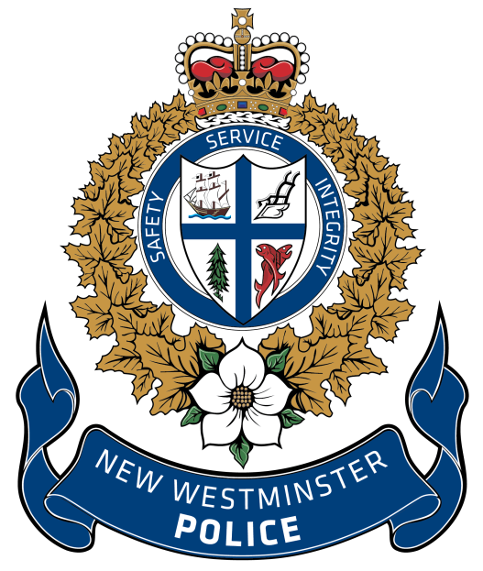

Celebrating 39 years

July 15, 2019 to July 19, 2019
Queens Park Stadium
New Westminster

WEBSITE:
www.nwpolice.org
INQUIRES AND QUESTIONS:
soccerschool@nwpolice.org
Please check our website prior to the camp start for further details

Dates Times and Location

The camp will run from July 15 to July 19, 2019 from 9:00 a.m. until 1:00 p.m. at Queens Park Stadium located at 1st Street and 3rd Avenue, New Westminster.

Cost: (Children must be from the same family)

1st Child $110
2 Children $210
3 Children $300
4 Children $390
5 Children $480

Payment is cheque or exact cash only. Cheques made payable to New Westminster Police Soccer School. NSF cheques subject to additional fees.

Due to the number of participants involved in this camp, we will NOT be able to meet the requests of parents for their children to be in the same group as another child.

Children MUST BE 5 years of age on the 1st day of the program. The age limit for the program is 10 years of age. Proof of age may be required.

CONSENT & WAIVER

The undersigned hereby agrees that the New Westminster Police Department will not be held responsible for any accidents or loss however caused and agrees to release all instructors, staff and sponsors from all claims or damages which may arise as a result of/or by reason of such accident or loss.

___________________________________________
Parent/Guardian Signature

___________________________________________
Print Name/ Date
Please Print Clearly

Last Name:_________________________________

First Name:_________________________________

Age:_______________________________________

Date of Birth: ____________________________
Yr/Mo/Day

Child will be entering grade _________ in Sept 2019

Male: Female:

Address: ____________________________

____________________________

City: ____________________________

Phone # ____________________________

Alternate Ph # ____________________________

Emergency ____________________________
Contact Name
and Phone # ____________________________

Allergies or ____________________________
Medical
Conditions ____________________________

Please advise/ details if your child requires any additional assistance throughout the camp

_________________________________________________________

_________________________________________________________

_________________________________________________________

_________________________________________________________

T-Shirt Sizing

Please check the appropriate size. Ensure the sizing is correct, as there will be no exchanges. The shirt quantity is limited to the sizes selected.

** SIZES ARE MEASURED WIDTH x LENGTH **

YOUTH SMALL (17 inches x 22 inches)

YOUTH MEDIUM (18 inches by 23.5 inches)

YOUTH LARGE (19 inches x 25 inches)

ADULT SMALL (18 inches x 28 inches)

ADULT MEDIUM (20 inches x 29 inches)
PHOTO RELEASE

I hereby give permission for my photograph, video or artwork to be taken and/or used by the New
Westminster Police Department or the City of New Westminster for publication in brochures,
websites, leisure guides, advertisements and other promotional material the city creates, including
permission for the department to copyright the photograph, video or artwork in its name.
I hereby release the New Westminster Police Department and the City of New Westminster from all claims arising out of its use, including all claims for libel or invasion of privacy.

I confirm that I have read this form and understand its contents.

New Westminster Police Soccer School

Name of Child

_______________________________________

Signature of Parent/Legal Guardian/ Date

_______________________________________

