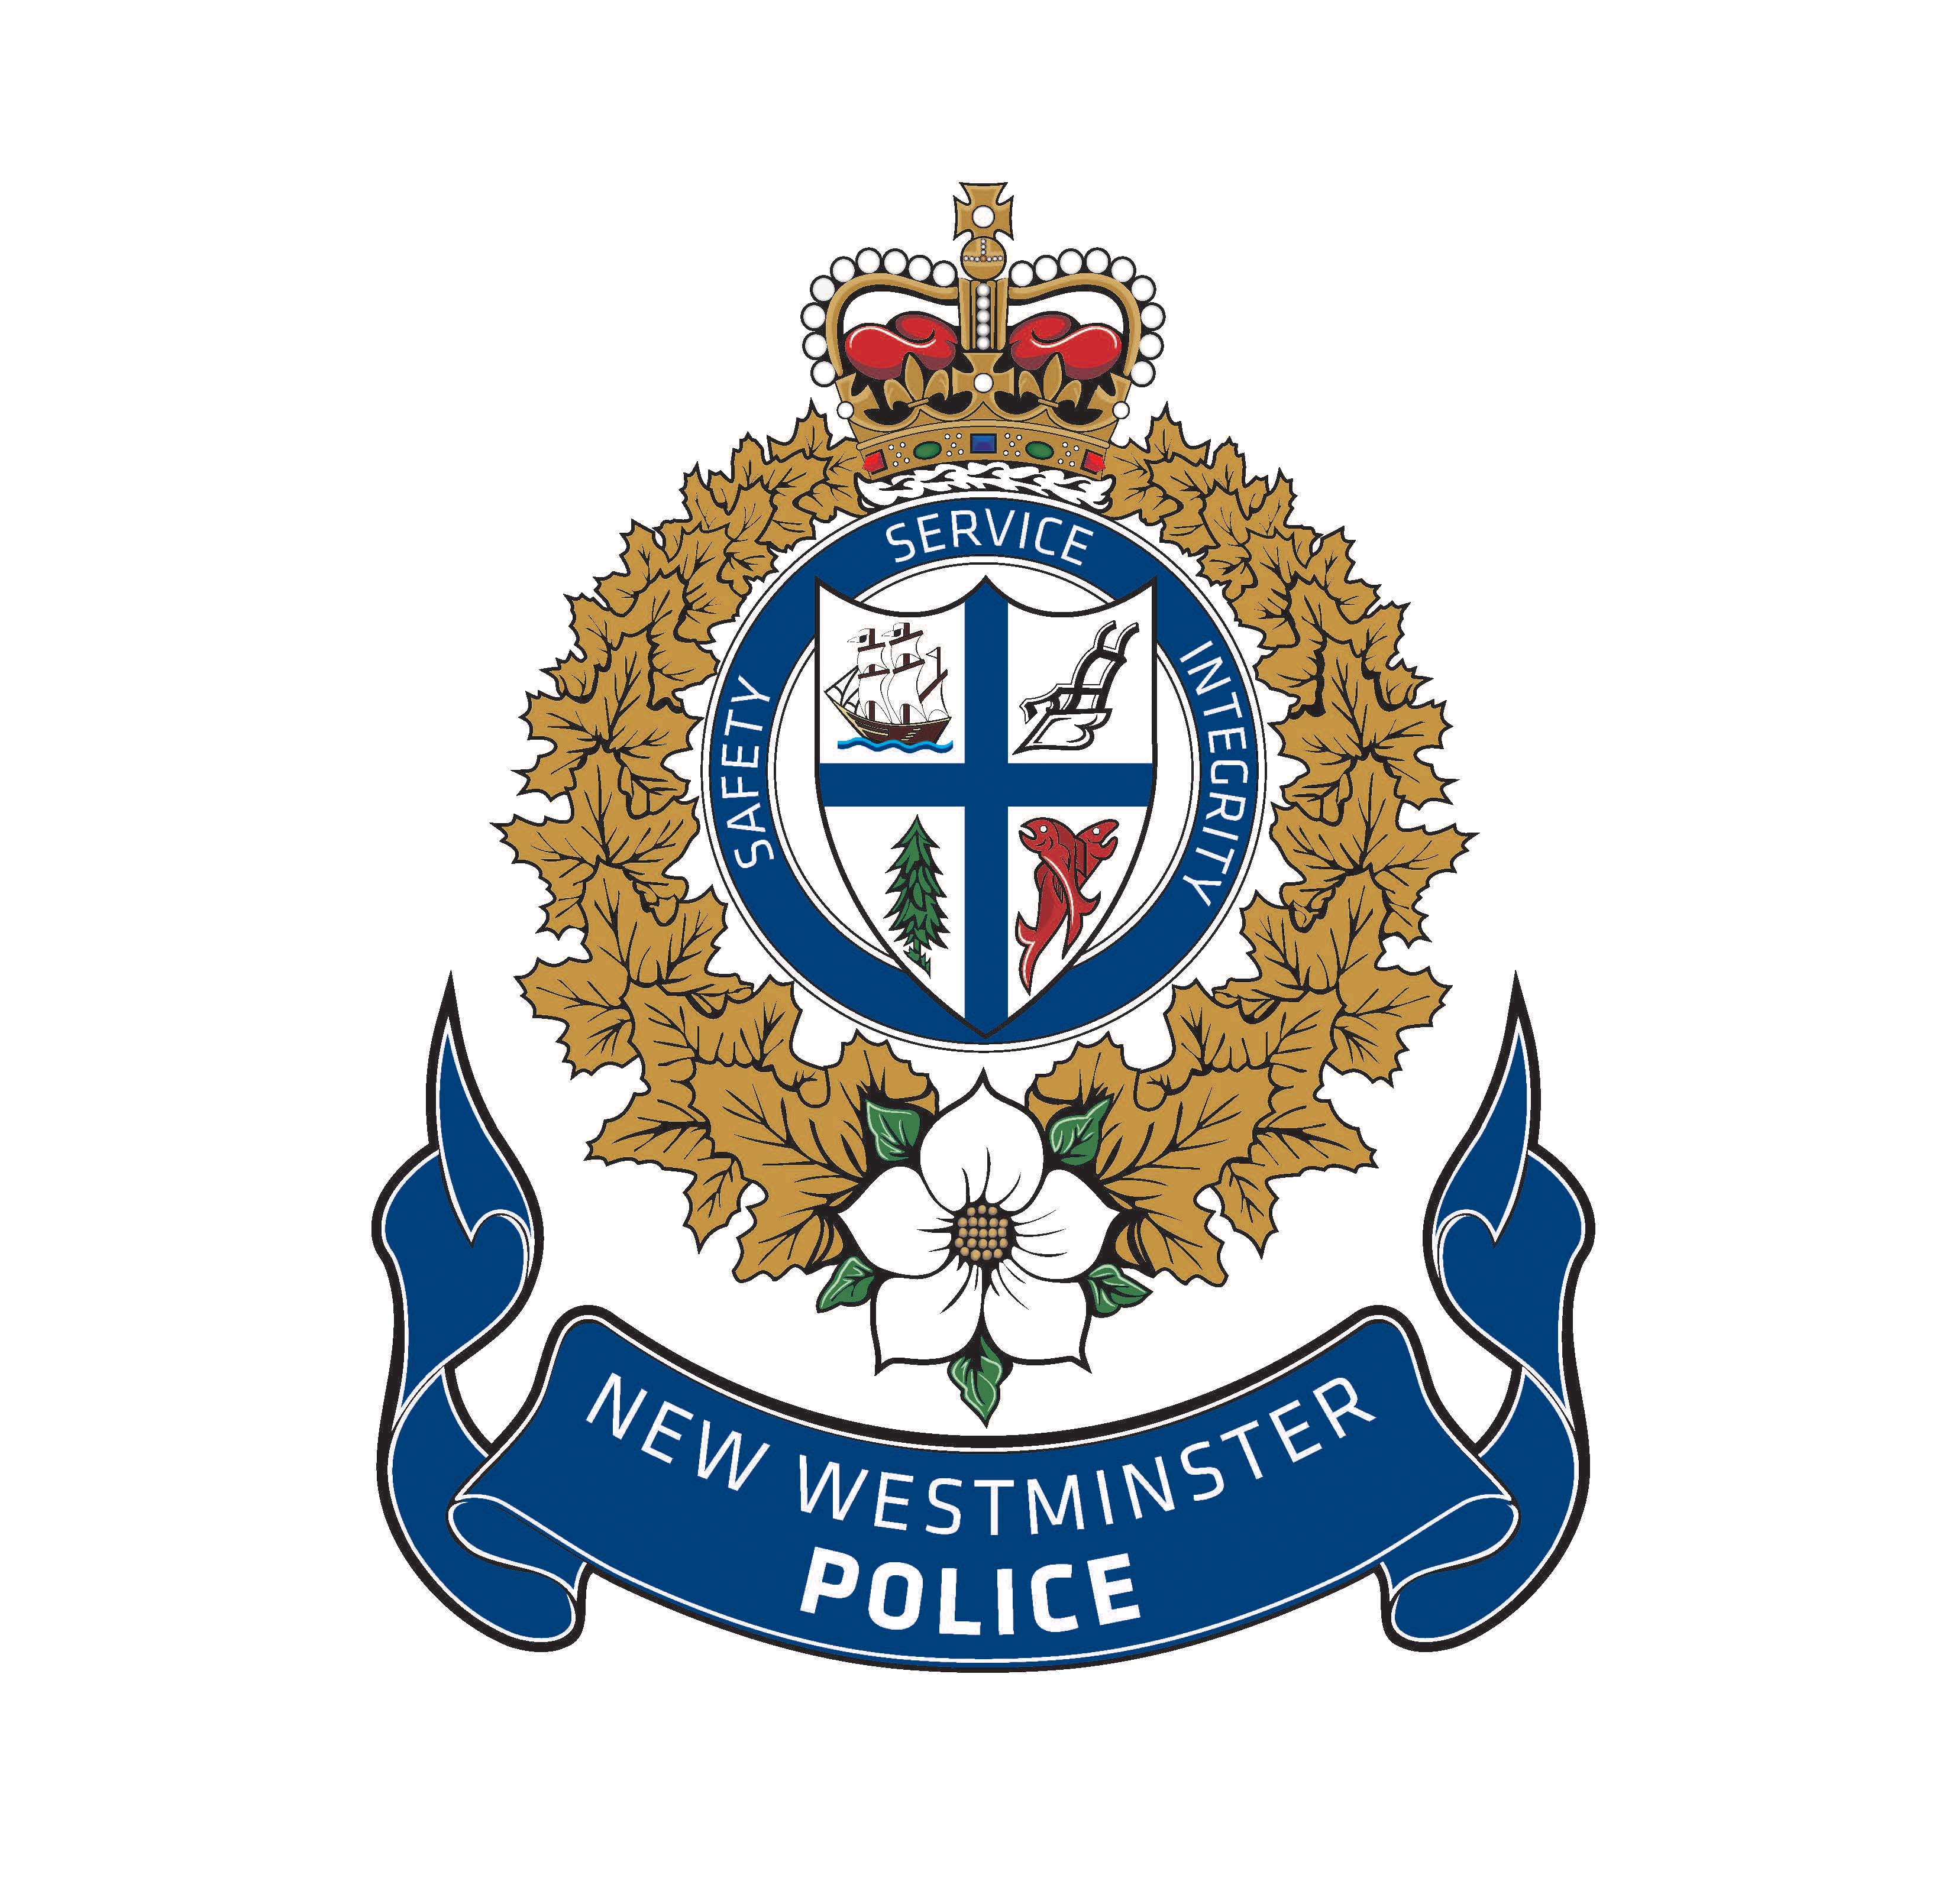

NEW WESTMINSTER POLICE DEPARTMENT 2018

APPLICATION PACKAGE

July 2nd – July 12th, 2019

INTRODUCTION
The New Westminster Police Student Academy is a two week program that gives you a behind the scenes look at all aspects of policing. From physical conditioning and self-defense tactics, to scenario-based simulations and firearm safety, you’ll receive the most up to date police training.
You will learn about the many different aspects of policing from exciting guest speakers, meet members of the K9 Unit, see the police helicopter – Air 1 up close, and get out on the water with the NWPD Marine Unit.
This is your opportunity to see what it takes to be a police officer.
Successful candidates will exemplify the following core values:
Professionalism – Police officers are expected to conduct themselves in a professional and appropriate manner both at work and in their personal lives.
Responsibility – Police officers are responsible for their own actions and for their contribution to a positive culture in their class.
Accountability – We are looking for candidates who understand the importance of taking ownership for their actions, both positive and negative.
Integrity –A police officer must be honest and truthful, realizing that the goal of each investigation is to discover truth rather than eliminating doubt.
Service – Police officers exemplify one of the most effective forms of leadership: servant leadership. Police officers lead by example and willingly assist with the most marginalized of all populations.
Endurance – Policing is both physically and mentally challenging.

APPLICATION

LAST NAME: FIRST NAME:_______________
Gender: F/M
Sex: F/M

BIRTHDATE: Y: M: D: __ AGE: ____

FULL MAILING ADDRESS: __________________________________________

PHONE: DL:_________________

EMAIL: ________________________________

PARENT/GUARDIAN NAME:_______________________________

CONTACT NUMBER FOR PARENT/GUARDIAN:____________________

EMERGENCY CONTACT PERSON: (Other than parent)
EMERGENCY CONTACT PHONE # _______________
CARE CARD#:__________________________
SCHOOL ATTENDING: ___________________
GRADE: ___________
ALLERGIES/MEDICATIONS: _________________________________ ILLNESS/INJUIRES:_______________________________________________________________________________
HOBBIES/INTERESTS:_____________________________________________________________________________

DOCTORS NAME: ___________________ PHONE#: ___________________________

PARENT/GUARDIAN PERMISSION AND LIABILITY WAIVER

I understand as the Parent/Guardian of the person named below as Student, hereby given permission for said Student to participate in the New Westminster Police Student Police Academy program. I understand that said Student will be involved in a variety of activities including but not limited to driving and firearms training. I understand that said Student will be required to provide his/her own transportation to all training locations. I further acknowledge that some physical activities will be involved and state that said Student is in good physical condition and is capable of participating in strenuous physical activity. I also understand that a medical examination is recommended but not required to ensure said Student will be capable of participating in physical activities.

Further, the undersigned agrees to assume all risks of participating in the New Westminster Police Student Police Academy, and does hereby remise and forever discharge the New Westminster Police Department, its servants and agents from any and all manner of actions, debts, claims and demands, that said undersigned may have by reason of any manner arising out of the said activities organized by the New Westminster Police Department during the New Westminster Police Student Police academy session.

Further, the undersigned agrees to allow the New Westminster Police Department to use any photographs or video images or them taken during the Student Police academy for the promotion of the program.

In witness whereof, I have set my hands this date:

Year: Month: Day: ________ at (City) .

______________________ ______________________
WITNESS SIGNATURE STUDENT SIGNATURE

_____________________ _____________________ WITNESS SIGNATURE STUDENT SIGNATURE

PLEASE NOTE: IF YOU ARE UNDER 19 YEARS OF AGE YOU MUST HAVE YOUR PARENTS FILL OUT AND SIGN THIS WAIVER.

UNIFORMS:
As each cadet will receive the following items listed below, please indicate your size.

Jacket | W / M | S | M | L | XL
Gym Shorts | W / M | S | M | L | XL
T-Shirt | W / M | S | M | L | XL
Golf Shirt | W / M | S | M | L | XL
Ball Cap | W / M | S | M | L | XL

Cargo Shorts Waist ________________

( Men eg. “32”, Women eg. “8”)

NEW WESTMINSTER POLICE DEPARTMENT CRIMINAL RECORD CHECK

Because of the confidential nature of police work, you are required to undergo a SECURITY SCREENING. This screening is conducted on the basis of the information you have provided in your application form.

Any incorrect or incomplete information will result in rejection of your application for participation in this program.

Full Name of Applicant: _________________________________

Address: ______________________________________________

D.O.B: __________________

Postal Code: Phone #: ________

I, _________________ understand that I am applying for the NEW WESTMINTER POLICE DEPARTENT STUDENT POLICE ACADEMY and that I am required by the New Westminster Police Department to disclose whether or not I have been charged or convicted of any offence.

I, _________________ understand that disclosure of a criminal record may not hinder me from being successful as an applicant for the NEW WESTMINSTER POLICE STUDENT POLICE ACADEMY. I _________________ also understand that should the NEW WESTMINSTER POLICE decide to terminate my application based upon any disclosed conviction or pending charges that I will have the opportunity to see and discuss that criminal record.

I __________________ therefore authorize the New Westminster Police Department to inquire and determine whether I have a criminal record and obtain a complete disclosure of any criminal record they may find or uncover.

__________________________
Signature of Applicant

____________________
Signature of Parent/Guardian

In Addition to the information above please submit the following information:

1. Resume (one page resume of your education, work experience and interests)
2. Record of your most current school marks
3. One letter of reference
4. Completed parental permission and waiver form
5. Attach a 500 – 800 word essay answering all the following questions:
• What are your future schooling and career goals?
• What would you like to learn from the Student Police Academy?
• Why should YOU be chosen for the Student Police Academy?
• Tells us in a paragraph what you know about the New Westminster Police Department.

IMPORTANT DATES

